New visualizations :

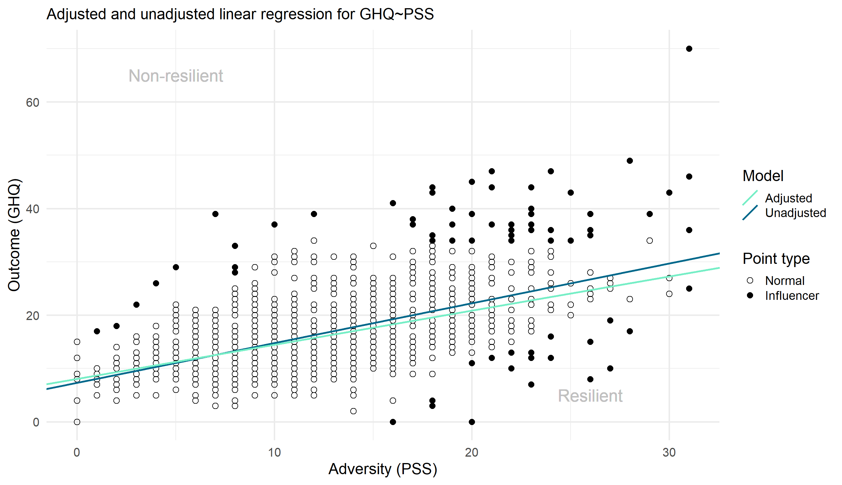
Figure X: Residualization of GHQ and PSS
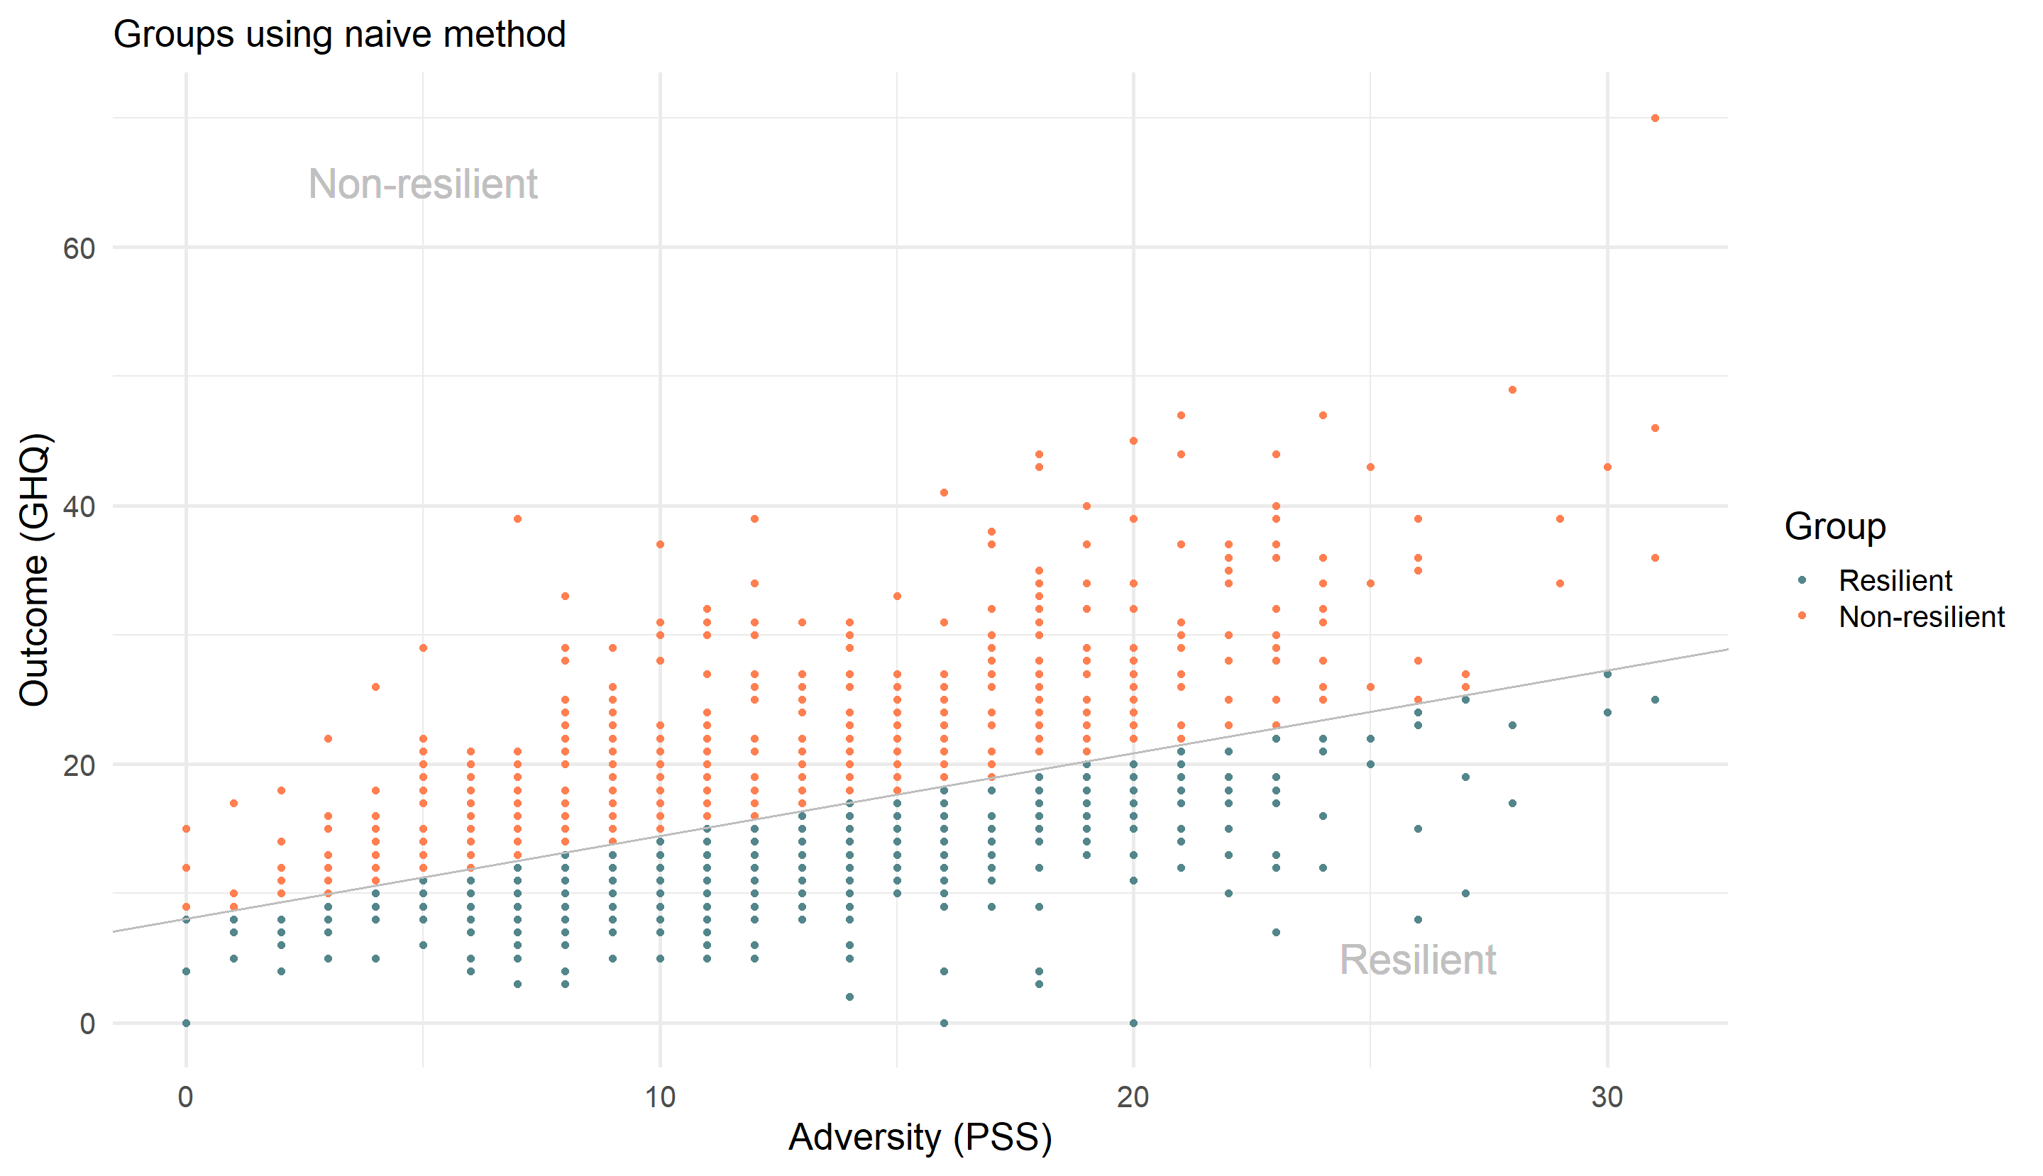
Figure X: Classification obtained with the naive approach for PSS

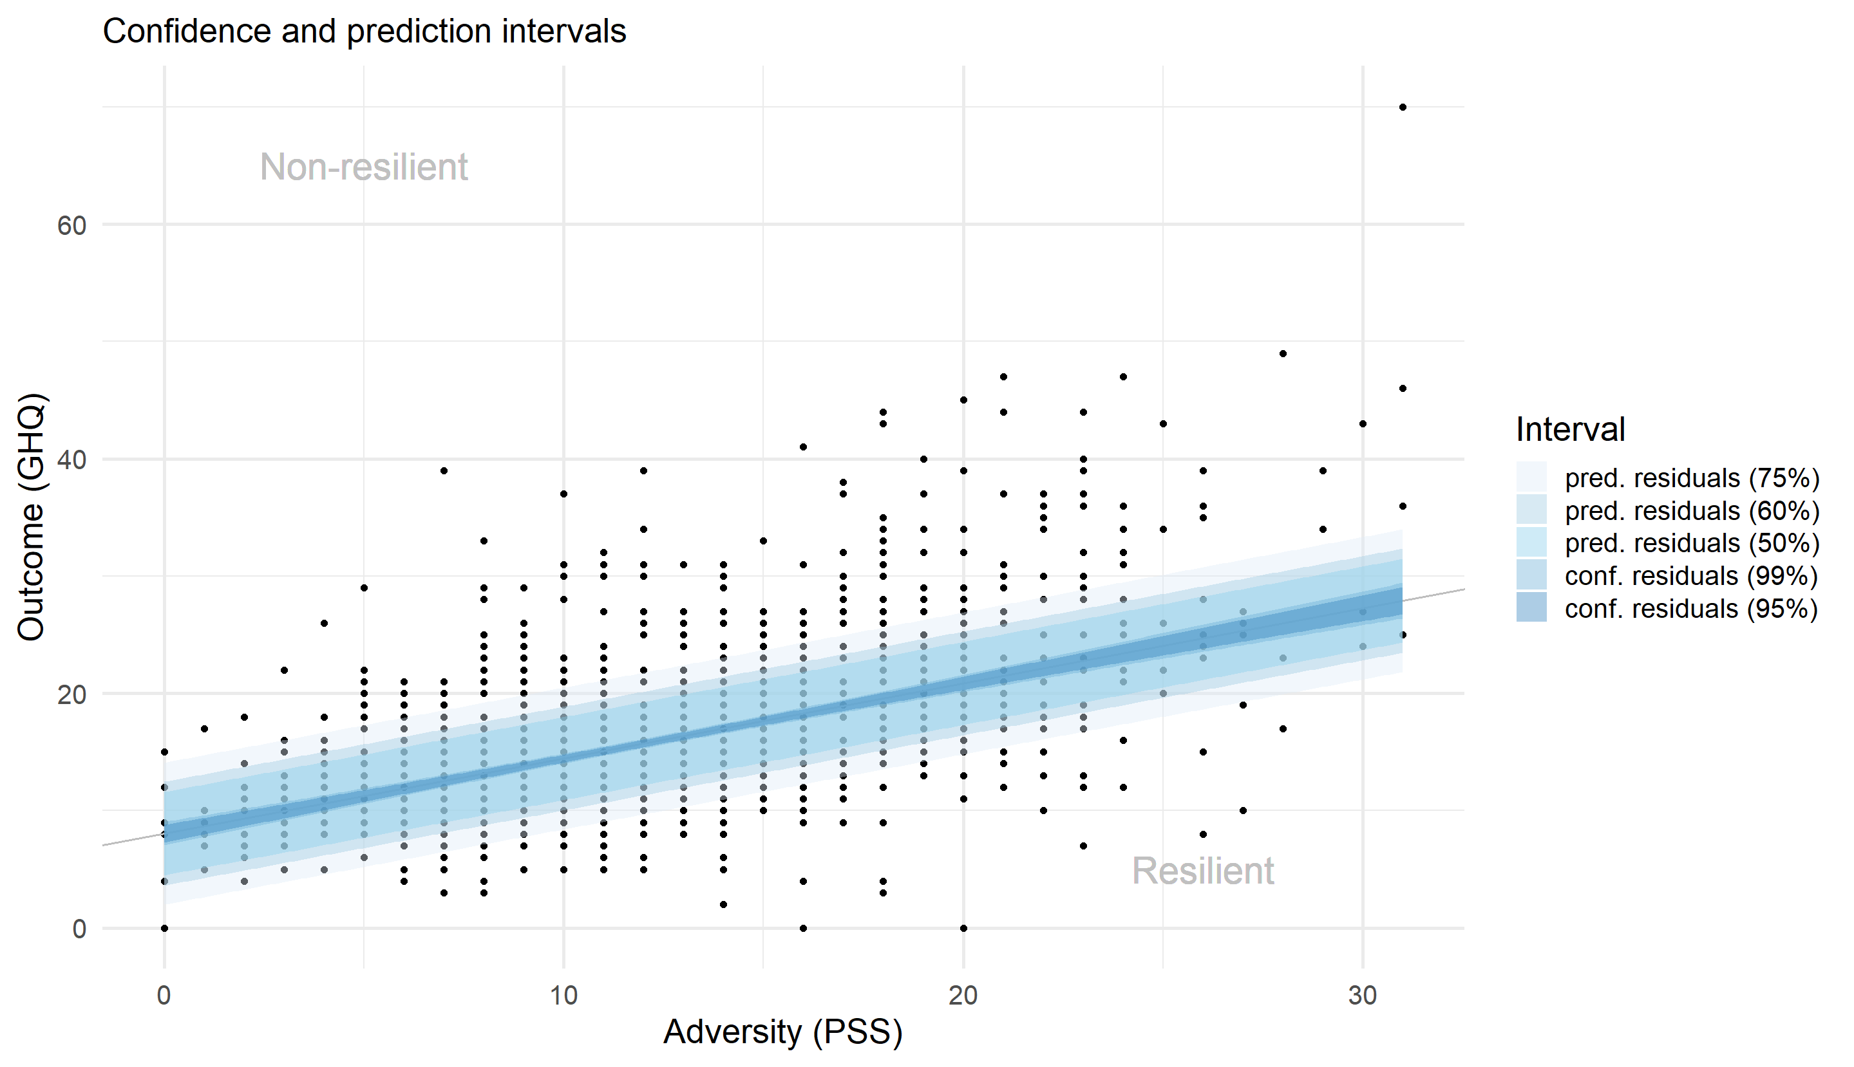
Figure X: Classification obtained with the confidence and prediction intervals approaches for PSS

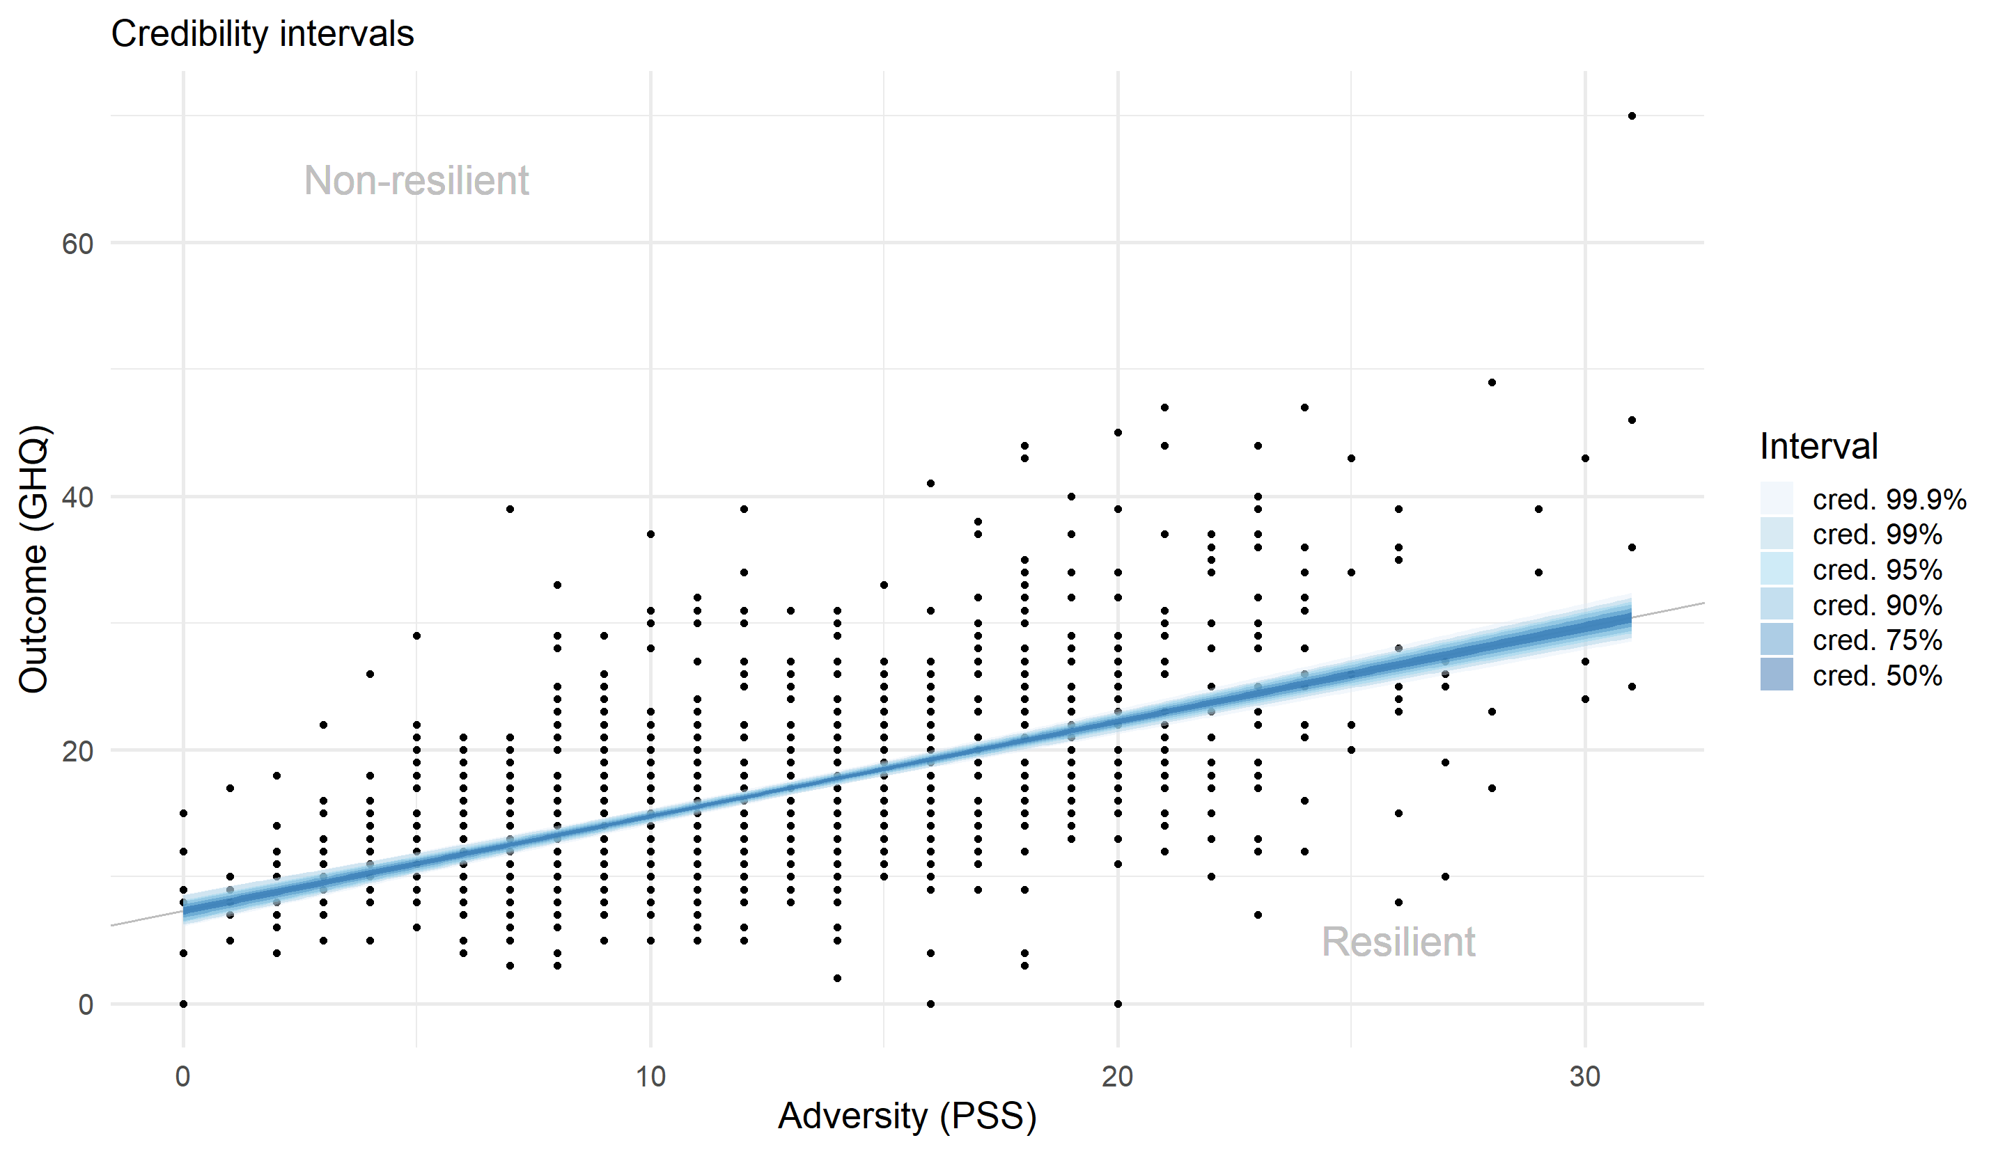
Figure X: Classification obtained with the credibility interval approach for PSS

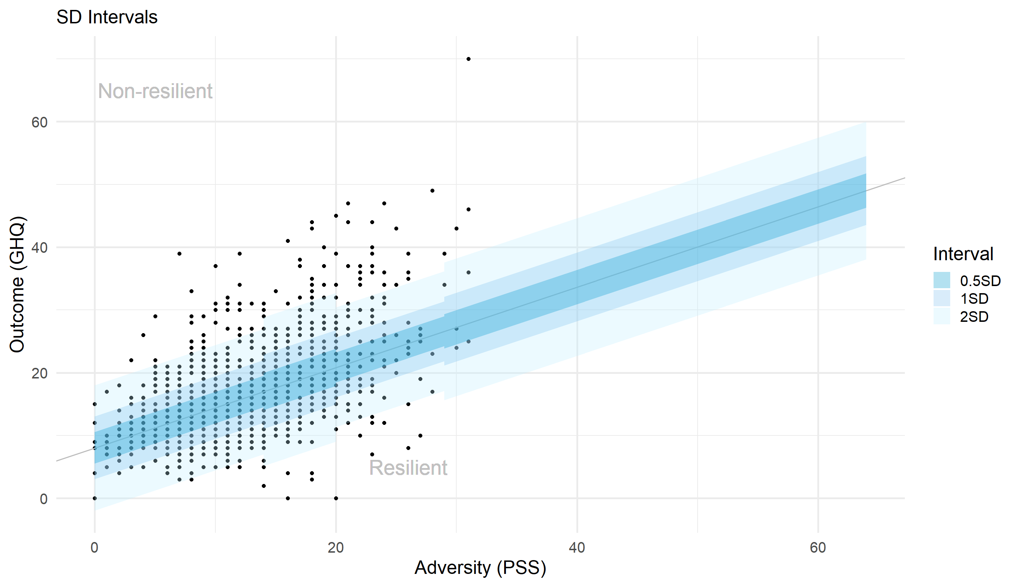
Figure X: Classification obtained with the standard deviation based approach for PSS

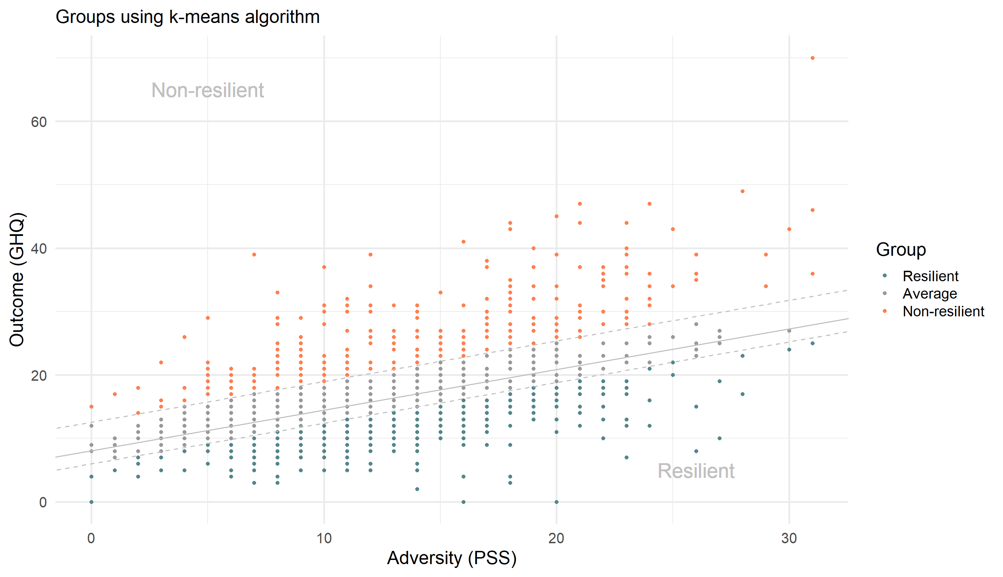
Figure X: Classification obtained with the k-means method for PSS

Table presenting the approaches

Approach | Description | Strictness (average group size)
Naive | Non-zero residuals = non-average. | Very strict, almost no average group
Confidence | Outside confidence interval of residuals = non-average. (Interval for mean estimate) | Strict, narrow interval, small average group, but depends on chosen %.
Prediction | Outside prediction interval of residuals = non-average. (Interval for new observation) | Moderate, wider than confidence intervals, but depends on chosen %.
Credibility | Bayesian equivalent of confidence interval. | Strict, narrow interval, small average group, but depends on chosen %.
Quantiles | Outside n% - (100–n)% quantile range = non-average. | Flexible, smaller n implies larger average group.
Standard-deviation | Residuals beyond multiple × SD within adversity group = non-average. | Flexible, larger multiple implies larger average group.
K-means | Cluster residuals into 3 groups using k-means. | Variable, depends on data structure.
Table X: Concise description of all approaches

